Polymorphism in Java
📘 Definition:
Polymorphism means "many forms".
In Java, polymorphism allows one object to behave in multiple ways, depending on the context.
In simple terms —
A single function, operator, or object behaves differently based on the input or situation.

🔹 Types of Polymorphism
Java supports two main types:
Type | Also Known As | When It Happens | Example
Compile-time Polymorphism | Static binding / Early binding | At compile time | Method Overloading
Runtime Polymorphism | Dynamic binding / Late binding | At runtime | Method Overriding

1. Compile-Time Polymorphism (Method Overloading)
🧩 Definition:
Method Overloading occurs when multiple methods in the same class have the same name but different parameters (number or type).
📄 Syntax Example:
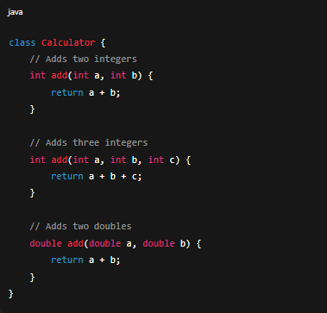

Real-Life Industrial Example:
In a Banking Software, the calculateInterest() method can be overloaded for different account types:
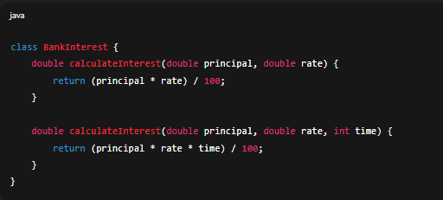
👉 Here, the same method name handles different use cases — making the code more readable and flexible.

⚙️ 2. Runtime Polymorphism (Method Overriding)
🧩 Definition:
Method Overriding occurs when a child class provides a specific implementation of a method that is already defined in its parent class.
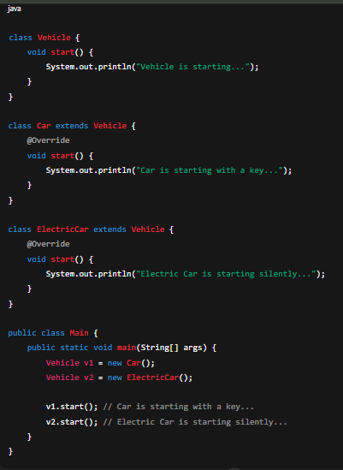
📄 Syntax Example:

Real-Life Industrial Example:
In a Ride-Sharing App (like Uber):
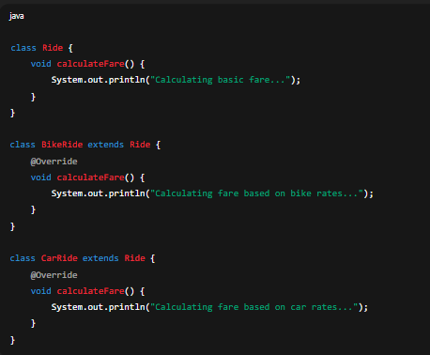
👉 Depending on which Ride type the user books (Bike or Car), the same method calculateFare() behaves differently at runtime.

🏗️ Why Use Polymorphism?
- ✅ Code Reusability
- ✅ Scalability — easy to extend classes
- ✅ Maintainability — same interface, different behavior
- ✅ Increases Flexibility in object-oriented design

🧾 Key Differences Between Overloading and Overriding
Feature | Method Overloading | Method Overriding
Binding | Compile-time | Runtime
Location | Within the same class | Between parent & child classes
Method Signature | Same name but different parameters | Same name & same parameters
Return Type | Can be different (if parameters differ) | Must be same (or covariant)
Access Modifier | Can be anything | Cannot reduce visibility
Use Case | To improve readability | To achieve dynamic behavior

🔧 Industrial Scenario
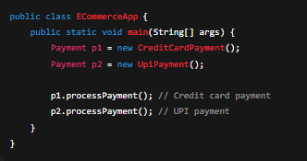
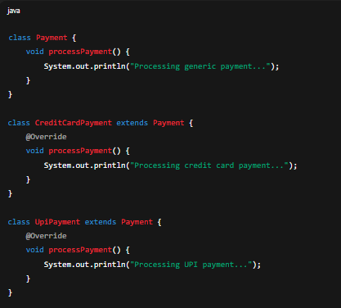
Imagine a Payment System:
✅ Here, the processPayment() method behaves differently depending on payment type — a perfect example of runtime polymorphism used in real e-commerce systems.

